Chapter 1
Opting Industry 4.0: Challenge or Opportunity
Dr. Kirti Wanjale¹ Dr. A.V. Chitre² * Dr. Ruchi Doshi³

¹ Associate Prof. ,Computer Engg. Dept, Vishwakarma Institute of information Technology, Pune, kirti.wanjale@viit.ac.in
² *Associate Prof. , EnTC. Dept, Vishwakarma Institute of information Technology, Pune, abhijit.chitre@viit.ac.in
³ PhD Supervisor & Assistant Professor, University of Azteca, Mexico ruchi.doshi@univ-azteca.edu.mx

Abstract
Globalization had enabled industries to give their service to customers irrespective of the physical location. As the targeted customer is global customer the working pattern of industries has changed drastically. Industries moved from 3.0 to 4.0 where automation is one of key issue need to be handled by all sectors. The current market has gradually started focusing on intelligent products which in turn forced industries to transform from having intelligent production than regular traditional production. Industry 4.0” which is the fourth industrial revolution has attracted huge attention since the concept was created in 2012. In manufacturing Industries the autonomous systems gain more weightage than earlier methodology. Industry 4.0 is a wave where everyone wants to participate and have a worldwide transform. It is used to represent digitization meaning the automation process used for manufacturing. When industries started moving towards 4.0” it mainly focused on new technologies like a IoT, CPS,Big Data Analytics. In industry 4.0 , industries should understand different aspects of 4.0 to be able to comply themselves with the requirements. One of the important aspects is automation, no human intervention in the manufacturing process. Entire product life should be without any participation of human. It is possible with sensors, actuators, communication and automation using techniques called as IoT devices and Cyber-Physical Systems (CPS). The trend of transforming manufacturing industry to the next generation is known as Industry 4.0.
Keywords. Industry 4.0, Industry revolution, Industry Automation
1. Introduction
Integrating the physical and computational worlds has lead to the fourth industrial revolution also termed as Industry 4.0. Instead of having mass and semi-customized products it has turned to mass and fully-customized products, is the meaning of Industry 4.0. Industry 4.0 gives products Internet-enabled facilitates innovative services, Internet-based diagnostics, maintenance in an efficient manner. Moreover, it helps in understanding of new business models, operating concepts and smart controls, and focusing on the user with his individual needs. These are the systems with industrial automation that enables innovative functionality through internet and their access to the cyber world, thus changing the lives every day. All future factories should operate in accordance with the Industry 4.0 concept. Although this notion was initially proposed in the context of manufacturing systems, it can be utilised in a variety of industries, including oil and gas, chemical plants, and power plants.
The purpose of this article is to provide a high-level overview of Industry 4.0 technology. Our purpose is to provide a viewpoint on what Industry 4.0 is, what its issues are in today's setting, and what the future holds. In this article we have discussed how new technologies helps in industry 4.0 transformation, challenges faced to implement industry 4.0, Benefits of industry 4.0 and finally some case studies where industry 4.0 is already in place. After reading this chapter you will come to know about various aspects of implementing Industry 4.0 standards in industries. Also case studies will demonstrate on how industry 4.0 is already implemented in various sectors.

1.1 Role of technologies in industry 4.0 transformation

It is the digital transformation of manufacturing processes and also production in the industry. Meaning of Industry 4.0 is with the help of information and communication technology, switching to the intelligent networking of machines and different processes for industry. Certain goals need to understand behind Industry 4.0 and they are as follows(fig 1):

- Automate the decision-making processes,

- Monitor various assets and processes in real-time,

- Enable equally connected value creation networks by involving stakeholders,

- Implement IT and OT convergence.

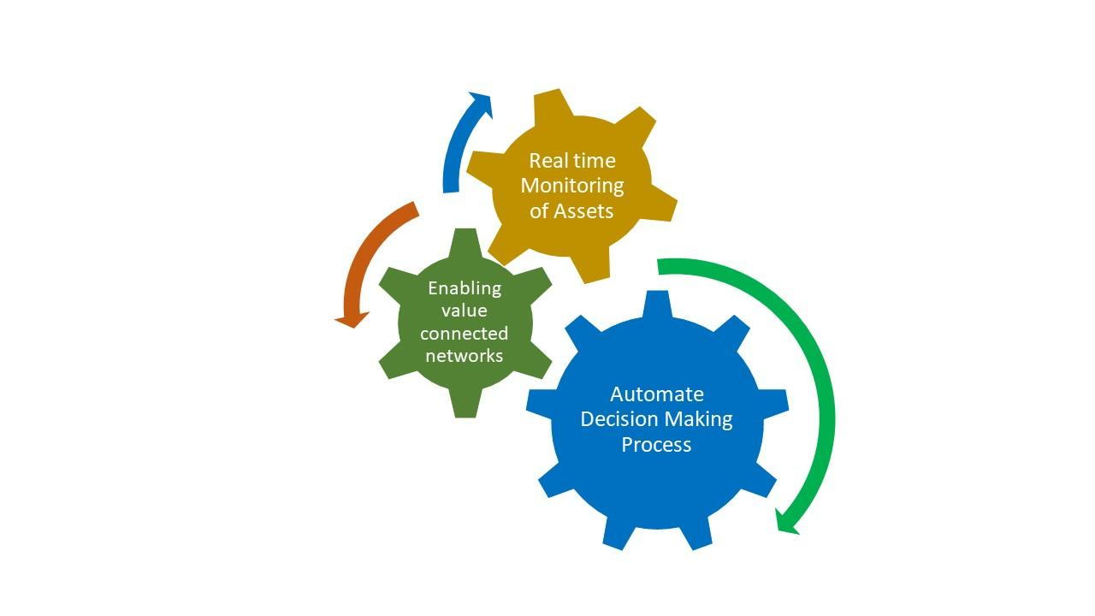

Fig 1. Goals behind Industry 4.0

Automate the decision-making processes : At the very core Industry 4.0 it is required to includes the partial transfer of autonomy and autonomous decisions. It is possible with the help of cyber-physical systems and machines, leveraging information systems.

Monitor various assets and processes in real-time : In Industry 4.0 it is important to monitor various assets of the industry. Also the different processes the industry is following since long.

Enable equally connected value creation networks by involving stakeholders:

When it comes to Industry 4.0, stakeholder involvement is also critical. With the support of stakeholders, we need to enable value generation networks. It is critical to comprehend the entire industry value chain. It contains information on suppliers as well as the sources of the materials. Components required for various types of smart manufacturing are also critical for improved output. Regardless of the number of intermediary procedures and stakeholders, the eventual destination of all output, the end client, must be understood.

Revolutions are disruptive by definition, and the fourth industrial revolution, often known as Industry 4.0, is no exception. Experts believe that this new wave of revolution will bring about just as much change as the previous ones. Unlike previous technological advances such as steam power, electricity, and digital machinery, which were all based entirely on new technology, Industry 4.0 is focused on how new and old tools may be used in novel ways.

Robots now work alongside industry workers, and autonomous cars refill production line supplies, according to Industry 4.0. Designers and industrial workers have been connected via sensor networks and communications technologies, with intelligent machines and software interacting autonomously over the cloud, and facilities connected in real time to suppliers and consumers.

Smart technologies, or rather, smart technological utilization, offers the manufacturing industry so much potential. Engineers can get instant feedback on costs and performance predictions. Factory machines and logistics equipment can automatically assign factory processes. Cloud-based AI systems can compare parts and processes to optimise performance and computer systems equipped with machine based learning algorithms enable robotic systems to learn and operate with limited input from human operators.

In the manufacturing industry, it is impossible to go a day without hearing the phrase "Industry 4.0." Manufacturing technologies are growing to fully integrate both automation information and data interchange, which makes sense in an age where most firms' final aim is digital transformation. There is no end to what Industry 4.0 may bring to factory settings and beyond, thanks to the integration of cyber-physical systems, augmented reality, the Industrial Internet of Things (IIoT), and cloud computing.

Many businesses, however, continue to struggle with successful adoption; according to Industry Week, two out of every three enterprises piloting digital manufacturing solutions fail when scaling up to large-scale implementation. It begs the question: why have so many businesses recognised that transformation is required to reach the future of digital manufacturing, but so few have been able to realise its full potential?

When it comes to speeding up factory transformation, edge AI and IoT are crucial. What, on the other hand, is required to accelerate the adoption of these technologies while also assisting businesses in avoiding the pilot stage?

1.2 Key technologies to transform production Industry

Industry 4.0 encompasses the latest technologies which brings digital, physical world together. It has been like a new industrial stage in which several emerging technologies are converging to provide digital solutions. Generally-speaking, Industry 4.0 supports the growing trend towards automation and data exchange in technology including (refer figure 2):

- IoT (Internet on Things) : It plays very important role in Industry 4.0. IoT makes possible to connect all physical devices to internet and bring automations in the work.

- Industrial Sensors : The sensors like proximity, temperature ,acoustic,position which senses data from large distance brought revolutionary change in working pattern of industries.

- CPS (Cyber Physical systems) : Cloud computing along with IoT is already opted in industry 4.0 which has changed most of the processes in industries. Also it secures all connected assets by applying highly secure policy to protect.

- Digital Twin : Industry 4.0 allows to simulate the change in the production line before actual change which is also called as Digital Twin. It saves huge amount as the prototypes are available beforehand.

- Industrial robotics : This technology has been already opted by many of the manufacturing industries. It automates the action based on driven by machines. It is also useful for heavy lifting.

- AI (Artificial Intelligence): AI helps in analysing the huge data generated. Not only analysis it is possible to add intelligence to machines based on certain trainings.

- Mobility/5G: Due to this technology now it is possible to share the information and intelligence to stakeholder at rapid speed.

- Augmented Reality :It is possible to interact with physical things by virtually through digital channels

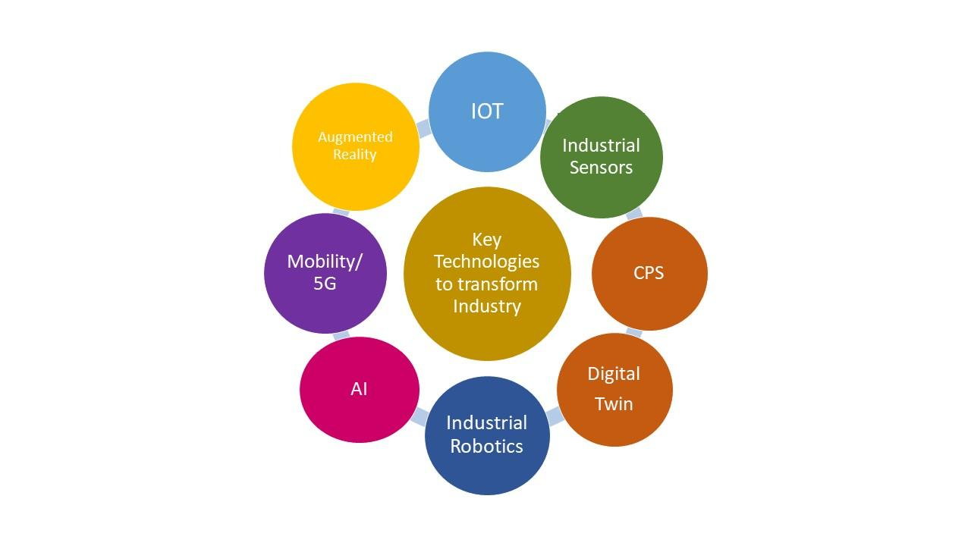
Figure 2 : Key technologies to transform production Industry

Implement IT and OT convergence: For better production we need to implement vertical and horizontal integration among various processes. A convergence is between information technology (IT) and operational technology (OT). Without this there is no industrial transformation. The convergence of IT, OT and their backbones includes networks or communication technology and infrastructure like cloud infrastructure, server infrastructure, storage and edge infrastructure. The essence of IT and OT convergence includes the data, processes and people or teams. In fact we can say that Industry 4.0 surely gives increased productivity but along with that it helps in increasing quality, flexibility and efficiency too.

2 Challenges when one wants to switch to Industry 4.0 :

While Industry 4.0 has good opportunities in the world , we should not ignore the challenges that the countries will face as they try to ride the Industry 4.0 wave. Whenever any industry want to adopt some changes in the industry functionalities there is always bit oppose to it. In case of adopting Industry 4.0 again many industries are facing various challenges which need to be addressed. Some of them are as follows.

2.1 Majorly the challenges:

The pursuit of Business 4.0 presents a variety of technological obstacles, with significant ramifications across numerous facets of today's manufacturing industry. Thus, it is critical to design a strategy for all parties involved in the full value chain and to reach agreement on security concerns and the appropriate architecture prior to execution. Additionally, some authors assert that implementing Industry 4.0 is a difficult task that will likely take 10 or more years to complete. Adopting this new manufacturing process entails a variety of factors and presents a variety of obstacles and challenges, including scientific, technological, and economic difficulties, as well as social and political ones.
Following is the mention of few of these significant challenges.
- Economic : One of a established industry whenever would like to undergo some changes the costs matters a lot. It requires high economic costs. New business model adaptation becomes necessary which again involves some costing. Before going for some changes with respect to any factor in industry management must be aware about the benefits but many times it happens that they don’t have foresight to clearly understand economic benefits.

- Social : In case if industry decides to go for Industry 4.0 still there is big issue of Data Privacy. The security of data is a critical issue needs to be addressed first.

It is always observed that whenever some change is proposed stakeholders are bit reluctance to the change. The main reason is employer has a threat of redundancy of jobs. It might be possible that people will lose their jobs especially for blue collar workers. Social advancement is consequently characterized as an extension of the opportunities and open doors for individuals to carry on with an existence that they esteem and have motivation to esteem. This is a development of decision (UNDP, 2012). Social improvement is a significant device for the execution of manageable turn of events, thus the quest for social advancement cultivates economical turn of events. Supportable improvement should be founded on working on individuals' personal satisfaction, and that implies that it ought to be intended to build individuals' capacity to meet their financial requirements without hurting the concerned employees.

- Political : In case of switching to new ideation there is problem from regulatory point of view. It is found that there is lack of rules and regulations, standards and forms of certifications, unclear legal issues and data security.

- Organizational/internal: From organization perception the reliability and stability is needed for critical machine-to-machine communication. Also it becomes necessary to maintain the integrity of production processes which the established organizations found bit difficult. Many of the times it is observed that there is less support from top management.

- Ethical challenges : Past Industrial Revolutions raised their own moral difficulties at that point, especially the substitution of talented work, such as winding, with additional proficient mechanical weavers, the subsequent abuse of ladies and youngsters in the untalented workforce expected to work the weaving machines. It required some investment before these moral issues were tended to, yet robotization expanded efficiency and made an entirely different circle of gifted positions, like bookkeeping and the executives. The advancements of the 4IR, alongside the force of Big Tech behind their arrangement, raise moral issues that go past the eventual fate of business; they strike at the core of being human.

2.2 Some more challenges

Even after finding solution to some of the above challenging issues organizations still have some more challenges as follows.

- Information management: An actionable intelligence and connected information is very much necessary in Industry 4.0. Process excellence in a context of relevance, innovation and timely availability for any desired business is equally important. In all the Information either received or generated while following processes should be managed properly is one of big challenge in Inductsry4.0.

- Cyber security or data privacy: Information or Data security is also become major challenge. Increasing in number of attacks in the Industrial Internet became big issue when industry decides to go for certain advancements.

- Awareness Gap : There are many gaps in our comprehension of the technological developments that are occurring in the tech industry. The workforce's requirements are always changing. Is it possible for your employees to keep up? When looking for candidates to fill unfilled roles, seek for people who have "digital dexterity," or the ability to grasp both industrial processes and the digital tools that support them. Business models will only be able to successfully deploy new technology and manage operations if they have the suitable employees.

- Data Sensitivity: With the advancement of technology, there has been an increase in worries about data and IP privacy, ownership, and management. Is there a common example? Data is required to train and test an AI algorithm before it can be properly implemented. The data must be provided in order for this to happen. Many businesses, on the other hand, are hesitant to share their data with third-party solution developers. Furthermore, our present data governance regulations for internal usage within enterprises are insufficient to facilitate data exchange across organisations. Data is a valuable asset, so be sure it's safe!

- Interoperability: The lack of separation between protocols, components, products, and systems is another key concern. Interoperability, unfortunately, limits firms' ability to innovate. Interoperability also limits possibilities for upgrading system components because they cannot easily "swap out" one vendor for another or one aspect of the system for another.
- Security: Threats in the manufacturing in terms of current and emerging vulnerabilities are another major worry. Real-time interoperability is possible because to the physical and digital components that make up smart factories, but it comes with the risk of a larger attack surface. When various machines and gadgets are connected to a single or multiple networks in a smart factory, flaws in any one of them could make the entire system vulnerable to attack. Companies must anticipate both enterprise system vulnerabilities and machine level operational weaknesses to assist tackle this issue. Many businesses rely on their technology and solution providers to identify vulnerabilities, therefore they aren't completely equipped to deal with these security concerns. A cyber assault can devastate a company's reputation as well as the personal information of its personnel.

- Handling Data Growth: As more companies become dependent on AI usage, companies will be faced with more data that is being generated at a faster pace and presented in multiple formats. To wade through these vast amounts of data, AI algorithms need to be easier to comprehend. Further, these algorithms need to be able to combine data that might be of different types and timeframes.

- Lack of Global visibility : Many of the times it happens that changes , revolutions are taking place at one of the region the other regions may not be aware about the same. It may be possible due to lack of communication or more of vertasality in working culture too.

- Lack of innovation: If the organization is established and older one in that case as high age employees may not bring the innovative ideas for implementation.

- Insufficient investment plan :This is very important issue faced by many of the industries. If any change is required in any industry then big investments are required. And same has to be proposed in company’s budget as well . In case if no provision is done the situation may go panic resulting failure in implementation of industry 4.0.

- Lack of visibility the performance : In case even though company decided to go for industry 4.0 changes then there has to be proper vision behind this decision. What could be benefits or losses that company may face that study should be ready before hand.
- Thin go-to- Market plan : Once the company opts for industry 4.0 , marketing team should have proper plan before sending product to the market. A proper marketing strategy needs to be defined in this case.

In spite of having some challenges or issue following are the fields where Industry 4.0 can be implemented

  - Manufacturing operations and quality
  - Production asses monitoring and management
  - Inventory logistics and transportation optimization

3.Benefits of Industry 4.0

Higher production and efficiency, improved flexibility and agility, and increased profitability are some of the advantages of Industry 4.0, according to its proponents. In addition, Industry 4.0 enhances the consumer experience. In addition to being engaging and exciting, Smart Factory technologies should always be placed at the centre of any conversation about Industry 4.0. After all, any investment you make in technology, improved production processes, or enhanced systems should generate a return on your initial investment in those areas. Because of the advantages that the technologies provide, the return on investment (ROI) prospects are enormous with Industry 4.0. This comprises technology that improve automation, machine-to-machine communication, production oversight, and decision-making processes, among other things.
Following diagram depicts some of the advantages of Industry 4.0. prominently on the basis of productivity, flexibility, quality and operation speed improvement perspective. Refer figure 3.
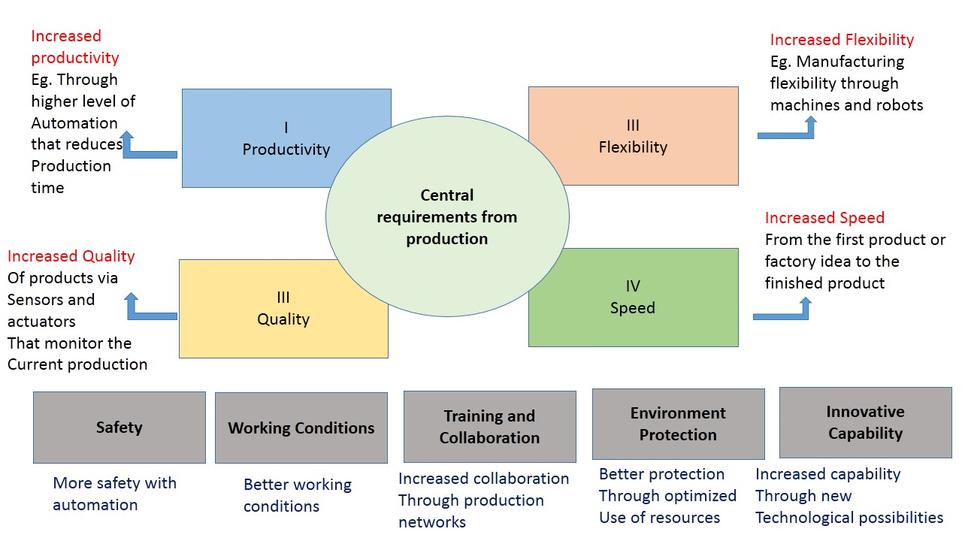
Figure 3: Advantages of Industry 4.0

Enhanced productivity using optimization and automation

In Industry 4.0, optimization of processes and of productivity is the first benefit that everyone can see. Basically we can say that it is one of the major goal of Industry 4.0 projects. In other words it saves costs, increases profitability, and reduces waste too. Automation can prevent errors and delays, speeds up the production and in all improves the overall value chain and so forth. Industry 4.0 gives various solutions to optimize, from optimized asset utilization and smoother production processes which also results into better logistics and inventory management.

Real-time supply chain management in a real-time working environment

Industry 4.0 also concentrates on enhanced customer-centricity. It is about the entire life cycle of products and manufacturing. If we consider the entire value chain and ecosystem there are many stakeholders involved in the process manufacturing. They are all customers. And a customer always wants enhanced productivity, regardless of where they are in this whole cycle or supply chain. If the final customers wants good products fast and have increased expectations regarding customer experience, quality, service then, this impacts the whole supply chain, all the way up to manufacturing and beyond.

Increased business continuity through advanced maintenance and automated monitoring possibilities

Let’s take an example that an industrial robot in a car manufacturing plant gives up, and then it’s not just the robot that’s broken. Production gets affected which leads to wastage of money and unhappy customers, and sometimes production can be fully disrupted. On top of all the replacement or fixing the error may damage the reputation. Orders may get cancelled too. If industrial assets are interconnected and can be e-monitored through the Internet of Things then it is possible to tackle it before they even happen and then the benefits are huge. Alarming or alerting systems can be set up. In this case the assets can be proactively maintained it results in real-time monitoring and diagnosis becomes possible beforehand. No wonder that asset management and maintenance are the second largest area of IoT investments in manufacturing.

Better quality products

It is true that customers want speed but that doesn’t mean they will compromise on quality. If your production system has many sensors, IoT techniques then definitely you can enhance the quality of your products. The typical components of cyber-physical systems and the Internet of Things can be automated so to monitor the quality aspects. On the other side we can say that more the automation , lesser the errors results into better quality. At the same time is it also true that robots are not going to take all human jobs over soon. Many companies have increased the usage of robots but at the same time they hired more people.

Better work environment

Improving working environment based on real-time temperature, humidity and other data in the plant or warehouse is more important part of Industry 4.0. Quick detection and enhanced protection in case of certain bad incidents, accidents will give more secured work environment for the workers too.

Personalization and customization for the ‘new’ consumer

We all that now days digital tools have changed the ways we work, shop and live. Consumer behaviour and preferences are changed. People are now more demanding, they do require fast responses and timely information/deliveries.. On top of that consumers also like a degree of personalization, depending on the context. They are more interested in customization as per their needs. Consumers demands to have a direct interaction with a brand and its manufacturing capability. Digital platforms are used to customize products as mentioned which in turn shortened routes between production and delivery. In many manufacturing sectors these things already happen. Along with the consumer environment industries also customization in a B2B context too.

Adopting state of art models to generate more venue

It is possible to transform processes, specific functions, customer service, experiences but in the end true value is tapping into new revenue sources and ecosystems. Handling innovative capabilities for customers to give advanced maintenance services and so on.

4 Applications

CPS has many applications nowadays as shown in figure 4. It can be found in smart healthcare wearable devices, smart grid, smart water networks, smart manufacturing, smart factory, gas and oil pipelines monitoring and control, unmanned and autonomous underwater vehicles, hybrid electrical vehicles and greenhouse control. F CYBER-PHYSICAL SYSTEMS
CPS is going to generate unique opportunities for economic growth. It will also create skilled jobs. CPS will help to ensure the health, safety, and security of the nation. CPS is going to drive the innovation in a broad range of industries and can lead to new products. Manufacturing techniques will increasingly rely upon CPS technologies for advanced and computer-controlled manufacturing processes like automated design tools. It will also bring dynamism in management of production lines, factories, and supply chains.

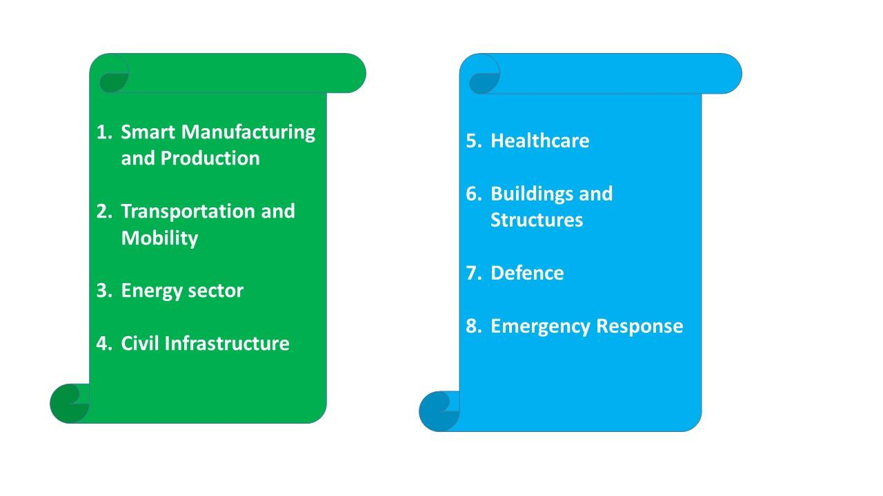
Figure 4 : Applications of Industries

- Smart Manufacturing and Production

- CPS in Manufacturing systems used for logistics integrated with communication abilities. In manufacturing sectors it will be used in sensors and actuator, ROBOT operated machines, Laid machine , mining machine welding machine, to improve efficiency of production.
- Agile Manufacturing, supply chain connectivity
- Intelligent controls, process and assembly automation

Advantages:
- It helps to Enhanced global competitiveness
- It has increased the efficiency, agility, and reliability.

- Transportation and Mobility

- It is possible to have vehicle based transportation CPS. Proximity detection for safety (vehicles coming close)
- Vehicle health monitoring
- Autonomous or smart vehicles (surface, air, water, and space
- Vehicle-to-vehicle and vehicle-to infrastructure communication
- Drive by wire vehicle systems, Plug ins and mart cars
- Interactive traffic control systems
- Next-generation air transport control

Advantages:
- It gives accident prevention and congestion reduction.
- Also it supports greater safety and convenience of travel

- Energy sector

- Use of CPS in Energy sector helps in demand management with distributed generations, automated distribution with intelligent substations, wide-area control smart grids, Data aggregation units.
- Electricity systems
- Renewable energy supply
- Smart Oil and gas production
- Smart electric power grid
- Plug-in vehicle charging systems
Advantages:
- CPS in this field also helps in greater reliability, security
- CPS enables diversity of energy supply which increases energy efficiency

- Civil Infrastructure

- Bridges and dams
- Municipal water and wastewater treatment
- Active monitoring and control system,
- Smart grids for water and wastewater
- Early warning systems

Advantages :
- It increases assurance of quality.
- CPS it gives more safe, secure, and reliable infrastructure

- Healthcare

- Highly accurate medical devices and systems
- Image-guided surgery and therapy (robotic surgery, accurately precisely)
- Control of fluid flow for medicinal purposes and biological (human error may be possible)
- Intelligent operating theatres and hospitals
- Engineered systems based on cognition and neuroscience (ex. Brain-machine interface, orthotics abd exoskeletons and prosthetics)
- Personal care equipment ,Disease diagnosis and prevention
- Wireless body area networks
- Assistive healthcare systems
- Wearable sensors and implantable devices

Advantages :
    - In this industry use of CPS helps in expands life span of every individual.
    - Hospital-based to home-based health care is possible because of CPS
    - CPS based medical instruments enabled more individualized health care
    - Advanced CPS can lead to new capabilities to diagnose, treat, and prevent disease

- Buildings and Structures

- High performance residential and commercial buildings
- Net-zero energy buildings ,Appliances
- Whole building controls, Smart HVAC equipment
- Building automation systems
- Networked appliance systems

Advantages :

    - It has increased building efficiency, comfort and convenience
    - Improved occupant health and safety
    - Also we can control of indoor air quality using CPS enabled household devices
    - CPS enables early bomb disposal system and emergency response robotics to sensor networks providing advance warning of catastrophic events.

- Defence

- Intelligent unmanned aircraft, ground vehicles,
- Autonomous and smart underwater, surface sensors
- overarching systems that integrate the nation’s fighting forces.
- Soldier equipment
- Weapons and weapons platforms
- Supply equipment
- Smart (precision-guided) weapons•
- Wearable computing/sensing uniforms
- Intelligent supply chain and logistics systems

Advantages :
- It has Increased war-fighter effectiveness,
- Increased security and agility
- Greater capability for remote warfare reduces exposure for human war-fighters

- Emergency Response

- First responder equipment
- Communications equipment
- Fire-fighting equipment
- Detection and surveillance systems
- Resilient communications networks
- Integrated emergency response systems

Advantages :
• Increased emergency responder effectiveness, safety, efficiency, and agility
• Rapid ability to respond to natural and other disasters

5. Societal impact :

While benefit and income proceed to be the principal rivers of associations' procedures and ventures, numerous business pioneers , as proven by the Business Roundtable's August 2019. Our review repeats this developing comprehension and obligation to society. A long time back, just
35% of CEOs trusted that the main associations representing things to come expected to spend more time planning for the possible effect that new
innovative arrangements might have on society. In this year's study, many CEOs said expanding their organizations' positive effect on society was among their main five wanted results of their Industry 4.0 ventures — a sign
that leaders are beginning to figure out that business plays a significant part to play in forming what these innovations could mean for society.

5.1 Relation between Profit and Purpose : Furthermore, innovation is assuming a main part: 62% of CEOs demonstrated that creating a gain while emphatically adding to society was an Industry 4.0 venture need for their associations — the second-most-refered to need subsequent to preparing and creating ability. Of those 24%
proposed they're gaining a lot of headway against this objective, a similar rate who accept their associations are in front of their rivals in doing as such.
It's maybe advising that of those professing to make extraordinary advancement, 69% have an extensive Industry 4.0 system. Having a conclusive system will likewise assist with dominating contenders: 60%
"with methodology" guarantee to be in front of the opposition, while just 13% "without methodology" make this same dispute.

5.2 Employee and customer advocacy is increased
At the point when inquired as to why their organizations decide to concentrate on cultural issues, 42% of CEOs referred to the valuable chance to produce income which recommends that benefit and income proceed to drive associations' procedures and inspirations. Nonetheless, bringing up that a close is significant second (and factual equivalent) was inspiration from
outer partners (clients, financial backers, and so forth.); third was worker pressure. Moreover, numerous recent college grads wish to work for organizations that have a reason past making money.9 as a matter of fact, there have been various late instances of workers rioting what's more, picket lines to fight their bosses' rehearses. Associations that don't uphold more extensive cultural responsibilities could begin seeing it influence their enrolment, maintenance, and generally speaking main concerns. Issues that appear to have soar in significance for leaders are environmental change and natural manageability. A long time back, as it were 10% of CEOs said their organizations could impact ecological manageability to a huge degree. This year, 48% see handling environmental change as a top liability;
38% put empowering manageability at the same need level.
With a rising number of horrendous, environment related occasions influencing populaces and geologies, CEOs are starting to feel, or possibly
figure out, the business basic of environment change. Almost 50% of CEOs (48%) totally concur that the impacts of environmental change will adversely influence their associations, and very nearly 90% totally or to some degree concur

- Case study : Challenges in Manufacturing sector

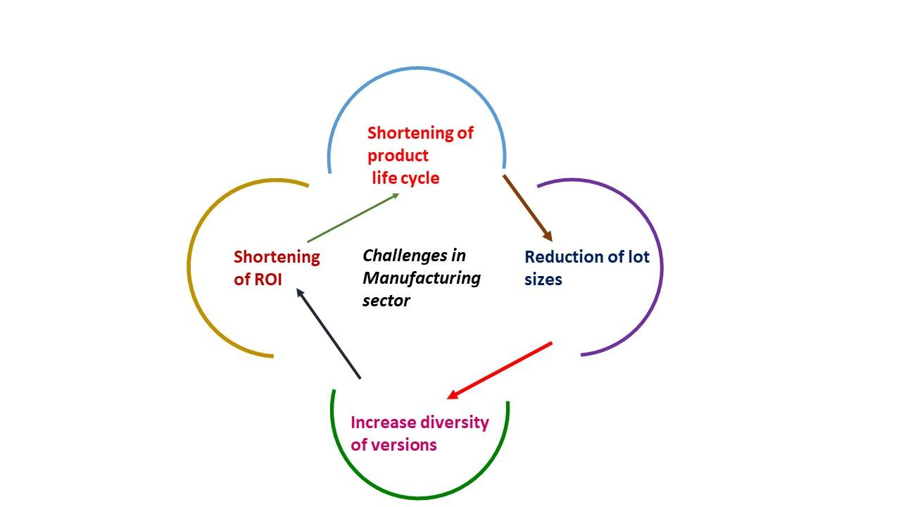
Figure 5: Challenges in Manufacturing sector

Let’s consider the case study of manufacturing sector that if these industries ready to opt for Industry 4.0 then what all issues they may have to face. Also refer figure 5.
  - Shortening of product life cycle : The complete product development life cycle gets change. As some sort of automation is involved in this it might be possible that product may get ready in less time period. So being an owner of the company one has to focus lot on this.
  - Reduction of lot sizes : It is well known that in industry the scale is always verses cost. If we increaser the scale the manufacturing cost varies accordingly. And same selling cost may be not possible with reduced scale.
  - Increase diversity of versions : Industry also need to opt for diversity in productions versions. If company is producing 300mg, 500mg pouches then now there is need to produces small pouches too for better selling of the product
  - Shortening of ROI : We all know that every investors always thinks about return of investments. If company is opting for industry 4.0 there has to be though given on ROI.
  - Energy efficient : One need to address the issue of power required after opting for industry 4.0. As many of the possesses undergoes in automation how much extra electricity required that is also an issue.

- Conclusion :

Industry 4.0 is future of industries. If one wants to survive in the competitions companies should opt the changes happening around. As previously stated, the integration of smart products with smart manufacturing, smart logistics, smart networks, and the Internet of Things results in the transformation of existing value chains and the emergence of new and innovative business models, positioning the smart factory as a critical component of future smart infrastructures. Numerous benefits and revenues will accrue as a result of this new infrastructure approach . Indeed, virtual and augmented prototyping facilitates the interactive exploration of all product functionalities by all stakeholders. Industry 4.0 enables a new method of doing business and a new source of value creation, particularly for traditional manufacturing firms. One of Industry 4.0's most significant disruptors is the ever-increasing value and importance of data. Businesses must view data as a rare and valuable raw commodity. As a result, businesses will need to rethink how they approach and manage massive amounts of data and information. This will be one of the most significant issues confronting traditional manufacturing firms. Utilizing dynamically programmable production technology in conjunction with increased machine flexibility (e.g., flexible grip hooks) has a number of advantages, including increased customization, more dynamic resource/capacity allocation, shorter changeover times, and reduced production complexity due to fewer constraints. This enables more rapid, cost-effective, simple, and diversified manufacturing methods. Industry 4.0 provides numerous benefits to businesses across multiple dimensions.
When the fourth generation of the industry arrived, it created an opportunity for reliability engineering to improve system dependability by utilising big data, the internet of things, and quick response to changes, among other things. In contrast, increasing complexity, dependencies and interconnections between components, dynamic behaviour, and newer components like as CPS and sensors, among other things, provide difficulties for reliability engineers. In order to keep up with the times, traditional approaches must be updated and a new framework for reliability, risk, safety, and security devised. In this article, the concept of Industry 4.0 is introduced, as well as some of the potential and difficulties it presents. It is not a pure or faultless review, and it is not focused on specific areas of Industry 4.0 and reliability engineering, but we are there to gain a perspective on these themes and to share our experiences. Some important problems such as system modelling, data, CPS, uncertainty, the interface problem, human-machine interaction, optimization, and other topics are taken into consideration. Throughout each part, the underlying principle of the object is described, and some potential new study possibilities are suggested. Conclusion: Today, multi-component system modelling, the interdependence of these components, the optimization of the supply chain while also optimizing maintenance and production, and the modelling of resilience are all receiving increased attention.
References
1. "A Roadmap to Industry 4.0: Smart Production, Sharp Business and Sustainable Development", Springer Science and Business, Media LLC, 2020
  - Michael Sony,” Design of cyber physical system architecture for industry 4.0 through lean six sigma: conceptual foundations and research issues”, PRODUCTION & MANUFACTURING RESEARCH 2020, VOL. 8, NO. 1, 158–181
  - "Industrial Internet of Things", Springer Science and Business Media LLC, 2017
  - Jeschke, S, Brecher, C, Song, H. Industrial Internet of Things. Cham: Springer, 2017.
  - Zhang, Y, Qiu, M, Tsai, C-W. Health-CPS: healthcare cyber-physical system assisted by cloud and big data. IEEE Syst J 2017; 11: 88–95
  - J Lee, B Bagheri, HA Kao, A cyber-physical systems architecture for industry 4.0-based manufacturing systems
Manufacturing letters, 2015 - Elsevier
  - Colombo, AW, Bangemann, T, Karnouskos, S. Industrial cloud-based cyber-physical systems: the IMC-AESOP approach. Cham: Springer, 2014
  - Shah Ahsanul Haque, Syed Mahfuzul Aziz,"False Alarm Detection in Cyber-physical Systems for Healthcare Applications", AASRIProcedia, 2013
  - Zhang, Z., Wang, H., Wang, C., Fang, H.Interference mitigation for cyber-physical wireless body area network system using social networks IEEE Transactions on Emerging Topics in Computing2013
  - Yilmaz, T., Munoz, M., Foster, R. N., Hao, Y.Wearable wireless sensors for healthcare applications Proceedings of the International Workshop on Antenna Technology (iWAT '13)2013
  - Haque, S. A., Aziz, S. M.Storage node based routing protocol for wireless sensor networks Proceedings of the 7th International Conference on Sensing Technology (ICST '13)2013Wellington, New Zealand
  - Zhang, Z., Wang, H., Wang, C., Fang, H .Interference mitigation for cyber-physical wireless body area network system using social networks IEEE Transactions on Emerging Topics in Computing2013
  - Avrunin, G. S., Clarke, L. A., Osterweil, L. J., Goldman, J. M., Rausch, T.Smart checklists for human-intensive medical systems Proceedings of the IEEE/IFIP 42nd International Conference on Dependable Systems and Networks Workshops (DSNW '12)2012 Boston, Mass, USA
  - Lee, I., Sokolsky, O., Chen, S., Hatcliff, J., Jee, E., Kim, B., King, A., Mullen-Fortino, M., Park, S., Roederer, A., Venkatasubramanian, K. K.Challenges and research directions in medical cyber-physical systems Proceedings of the IEEE,2012
  - Tang, L. A., Yu, X., Kim, S., Han, J., Peng, W. C., Sun, Y., Leung, A., La, P. T. Multidimensional sensor data analysis in cyber-physical system: an atypical cube approach International Journal of Distributed Sensor Networks2012.
  - Huang, Q., Ye, L., Yu, M., Wu, F., Liang, R.Medical information integration based cloud computing Proceedings of the International Conference on Network Computing and Information Security (NCIS '11)May 2011
  - Wang, J., Abid, H., Lee, S., Shu, L., Xia, F.A secured health care application architecture for cyber-physical systems Control Engineering and Applied Informatics2011
  - Wu, F.-J., Kao, Y.-F., Tseng, Y.-C.From wireless sensor networks towards cyber physical systems Pervasive and Mobile Computing,2011
  - Meng, W., Liu, Q., Xu, W., Zhou, Z.A cyber-physical system for public environment perception and emergency handling Proceedings of the IEEE International Conference on High Performance Computing and Communications2011
  - Taleb, T., Bottazzi, D., Guizani, M., Nait-Charif, H.Angelah: a framework for assisting elders at home IEEE Journal on Selected Areas in Communications,2009
  - Arney, D., Fischmeister, S., Goldman, J. M., Lee, I., Trausmuth, R.Plug-and-play for medical devices: experiences from a case study Biomedical Instrumentation and Technology2009
  - Poon, C. C. Y., Zhang, Y.-T., Bao, S.-D.A novel biometrics method to secure wireless body area sensor networks for telemedicine and M-health IEEE Communications Magazine2006
  - Kang, K.-D., Son, S. H., Stankovic, J. A.Managing deadline miss ratio and sensor data freshness in real-time databases IEEE Transactions on Knowledge and Data Engineering2004
  - M. Nahvi, A. Ivanov. "Indirect Test Architecture for SoC Testing", IEEE Transactions on Computer-Aided Design of Integrated Circuits and Systems, 2004

